

Final Project Report

Project Name :

Rahat Bakers Management System

Submitted to :

Sir Adnan Qureshi

Submitted by :

Arslan Ali Awan ( SP12-BCS-047)

Date of Submission:

22 May , 2013

Acknowledgments:

In the name of Allah the most beneficial and merciful who, give us the power of completion of this Database project.

Dedication:

We hereby declare that we made this project with the help of Allah Almighty and we dedicate this project to our Parents.

Project Description:

The project is about ‘Rahat Bakers Management System’. The management system had a lot of importance everywhere. Our project covers all the important aspects of a complete database. Our database project contain the following entities.

1. Branch
2. Customer_bio
3. Customer_address
4. Delivery
5. Employee
6. Expenses
7. Menu
8. Purchase
9. Recipe_name
10. Recipe_type
11. Sale
12. Stock
13. Supplier_bio
14. Supplier_address
15. Transport

Purchase

Supplier

Recipe

Customer

Employee

Has

Expense

Branch

Has

has

Delivery

Has

Transport

Stock

Has

Has

Sale

Menu

**UML**

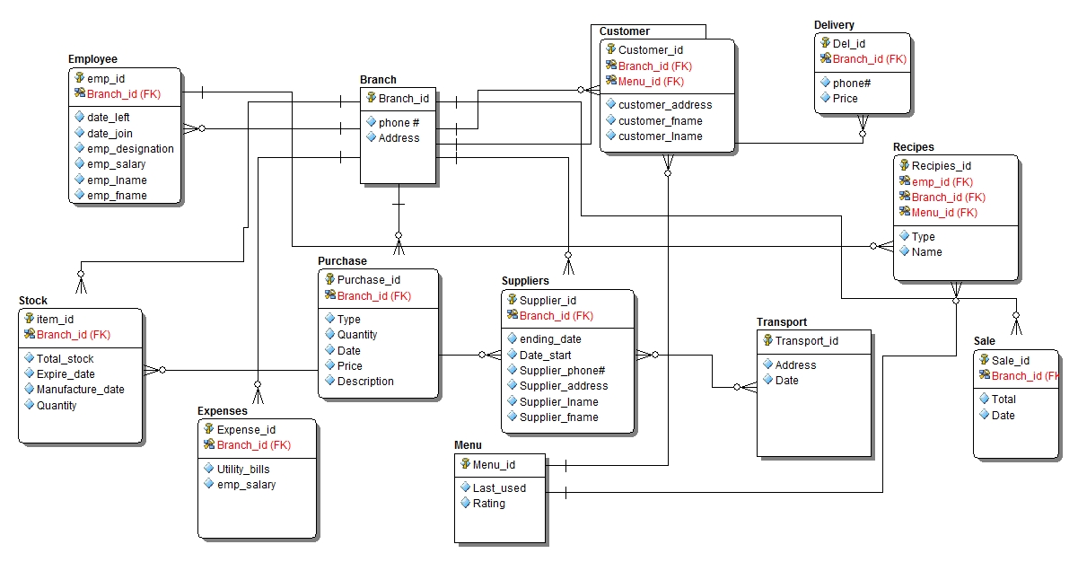

**ERD with Normalized form**

Recipe_type

Customer_address

Supplier_Bio

Customer_bio

Employee

Has

Expense

Branch

Has

has

Recipe_name

Purchase

Supplier_address

Delivery

Has

Transport

Stock

Has

Has

Sale

Menu

Script of a Normalized ERD of Rahat Bakers Database Management System

Table: Branch

Branch_id (PK) VARCHAR2(20)

Phone# VARCHAR2(20)

Address VARCHAR2(40)

Table:Employee

Emp_id (PK) VARCHAR2(20)

Branch_id (FK) VARCHAR2(20)

Emp_fname VARCHAR2(20)

Emp_lname VARCHAR2(20)

Emp_salary VARCHAR2(20)

Emp_designation VARCHAR2(40)

Date_left VARCHAR2(20)

Date_join VARCHAR2(20)

Table:Customer_bio

Cus_id (PK) VARCHAR2(20)

branch_id (FK) VARCHAR2(20)

menu_id (FK) VARCHAR2(20)

cus_fname VARCHAR2(20)

cus_lname VARCHAR2(20)

Table:Customer_address

Cus_id (FK) VARCHAR2(20)

branch_id (FK) VARCHAR2(20)

menu_id (FK) VARCHAR2(20)

cus_address VARCHAR2(20)

Table: Expense

Expense_id(PK) VARCHAR2(20)

Branch_id(FK) VARCHAR2(20)

Utiliy_bills VARCHAR2(20)

Emp_salary VARCHAR2(20)

Table: Delivery

Del_id (PK) VARCHAR2(20)

Branch_id (FK) VARCHAR2(20)

Phone# VARCHAR2(20)

Address VARCHAR2(20)

Table:Stock

Item_id (PK) VARCHAR2(20)

Branch_id ( FK) VARCHAR2(20)

Total_stock VARCHAR2(20)

Expire_date VARCHAR2(20)

Manufacture_date VARCHAR2(20)

Quantity VARCHAR2(20)

Table: Purchase

Purchase_i d(PK) VARCHAR2(20)

Branch_id (FK) VARCHAR2(20)

Type VARCHAR2(20)

Quantity VARCHAR2(20)

Date VARCHAR2(20)

Price VARCHAR2(20)

Description VARCHAR2(20)

Table: Supplier_Bio

Sup_id (PK) VARCHAR2(20)

Branch_id (FK) VARCHAR2(20)

End_date VARCHAR2(20)

Date_start VARCHAR2(20)

Phone# VARCHAR2(20)

sup_fname VARCHAR2(20)

sup_lname VARCHAR2(20)

Table: Supplier_address

Sup_id (FK) VARCHAR2(20)

Branch_id (FK) VARCHAR2(20)

Phone# VARCHAR2(20)

Address VARCHAR2(40)

Table: Transport

Transport_id (PK) VARCHAR2(20)

Date VARCHAR2(20)

Address VARCHAR2(20)

Table: Menu

Menu_id (PK) VARCHAR2(20)

Last_used VARCHAR2(20)

Rating VARCHAR2(20)

Table: Sale

Sale_id VARCHAR2(20)

Branch_id VARCHAR2(20)

Total VARCHAR2(20)

Date VARCHAR2(20)

Table: Recipe_name

Recipe_id (PK) VARCHAR2(20)

Emp_id (FK) VARCHAR2(20)

Branch_id (FK) VARCHAR2(20)

Menu_id (FK) VARCHAR2(20)

Name VARCHAR2(20)

Table:Recipe_type

Recipe_id (FK) VARCHAR2(20)

Emp_id (FK) VARCHAR2(20)

Branch_id (FK) VARCHAR2(20)

Menu_id (FK) VARCHAR2(20)

Type VARCHAR2(20)

Queries list

Sub-queries

Query #1

For branch info

Select * from branch where branch_id = (select branch_id from purchase where price = 6000 );

Query #2

For checking menu rating

Select rating , last_used from menu where menu_id= ( select menu_id from customer_bio where cus_fname='Unsub');

Query #3

For supplier complete info

select sup_id ,sup_fname,sup_lname from supplier_bio where sup_id= ( select sup_id from transport where tra_id =100);

Aggregation and grouping queries

Query #4

Sum of employee salary

select branch_id, sum (emp_salary) from employee group by branch_id having branch_id = '004' order by branch_id;

Query #5

Employee first and last name and salary using over function

select emp_fname,emp_lname , emp_salary, count(*) over (order by emp_salary) from employee order by emp_salary , emp_fname , emp_lname;

Query #6

Shows employee name using max function

select max(emp_fname) from employee where emp_fname like 'A%';

Show employee salaries

Query #7

select avg(emp_salary) ,max(emp_salary) , min(emp_salary) , sum(emp_salary) from employee where emp_id = 10;

Having clause

Query #8

Show sum of employee salary in order whose salary > 1000

select emp_id , sum(emp_salary) from employee group by emp_id having sum(emp_salary) >1000 order by sum(emp_salary);

Extra queries

Query #9

Employee salary * by 20

select emp_fname,emp_salary * 20 from employee where emp_salary > 5000 ;

Query #10

Count function on supplier name

select sup_id ,count(sup_fname) from supplier_bio group by sup_id;